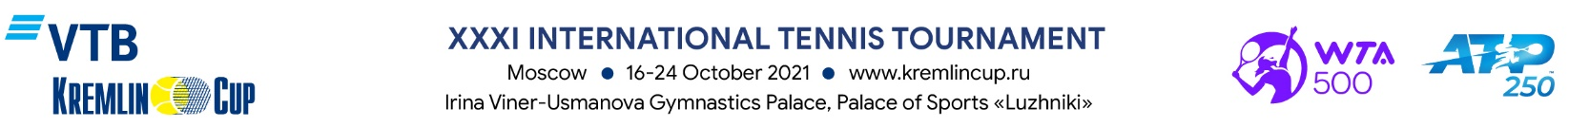

ACCREDITATION FORM FOR PHOTOGRAPHER

MEDIA (Registration Certificate):
Surname: |  |  | Name:
Address:
Mobile phone: |  |  | E-mail:

Type of Media:

Print Media

Radio

Information Agency

Internet

Blog

TV

Other (specify)

Job Title: Photographer

Expected coverage days:

16.10. 17.10. 18.10. 19.10. 20.10. 21.10. 22.10. 23.10 24.10 All

ATTENTION: as a result of the health and safety protocols due to the ongoing COVID-19 pandemic, only a select number of photographers will be permitted to be on-site at the tournament this year. The final decision will be made ahead of the tournament taking into consideration the epidemiological situation.

Wearing a protection mask at all times is compulsory for every approved photographer on site.

To get accreditation fill in all the fields in the Form, attach a scanned copy of the Company letter (pdf) and a photo (preferably 300 dpi, jpg, 4x6 cm).

All applications must be submitted by October 4, 2021, to the following e-mail address: media@russport.ru. Applications submitted after the deadline and applications from the representatives of advertising agencies will not be accepted.

Tournament Organizing Committee reserves the right to deny accreditation without explanation.

If your Application for Accreditation is approved, you will receive a confirmation to your e-mail address.

Approval of the Head

_______________________________________________________________________________________
Signature of the Director and Stamp Date

